**Learn in Community**

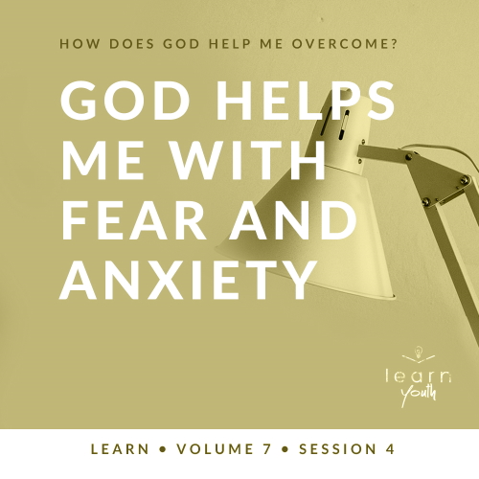

Small Group Study

**Volume Overview**

**How does God help me overcome?**

For I can do everything through Christ, who gives me strength. ([Philippians 4:13](https://ref.ly/logosref/Bible.Php4.13))

*Because of God’s strength in them, many people we read about in the Bible were able to overcome difficulties. In the same way, God can help us overcome challenges in our life, regardless of what we face. Why is it important for us to know that Jesus gives us strength in our everyday life? How does God help us deal with the hard situations we face? How do we handle temptation? What do we do when we feel alone? These are a few issues we’ll look at in this volume.*

|  |
| --- |
| ***You Will Need***   * *Three boxes (e.g., shoe boxes, small shipping boxes)* * *Scissors* * *Three items that would be challenging to guess what they are by touching them (for example, a mashed boiled egg, coffee grounds, cotton balls, etc.)* * *Paper towels*   ***Getting Ready***   * *Cut hand-sized holes into the three boxes.* * *Place the mystery items inside the closed boxes.* * *First time leading* Learn *for Youth? Look here for the* [*Facilitator Guide*](https://0b769b0ed3569ef9d18b-f88d8272f61086866d50d048b43ef630.ssl.cf2.rackcdn.com/sites/biblengagementproject/Listen_Facilitator_Guide.pdf)*.* |

*To access session content and videos from a computer, visit:* [*BibleEngagementProject.com/downloads*](https://bibleengagementproject.com/downloads)

**Engage**

**Welcome**

*Take this time to welcome everyone, introduce new students, learn names, and thank everyone for coming.*

|  |
| --- |
| **QUESTION**  What’s the craziest prank that’s ever been played on you? |

**Opening Prayer**

*Prayer thoughts: Pray that God would speak to each student in a special way today, and thank Him for each student in the group. Pray for the middle schools and high schools in the area. Pray that the Holy Spirit would speak to each student in a unique way as you read and study God’s Word together.*

**Introduction**

Today, we’ll be discussing how God helps us overcome fear and anxiety. Fear is something that we’ve all experienced, especially when life gets hard or scary. Even through life’s challenges, God’s love and care for us remains. He can help us when we feel anxious or afraid. Let’s dive into this truth together!

**Group Activity**

**Fearing the Unknown**

|  |
| --- |
| ***You Will Need***   * *Three boxes (e.g., shoe boxes, small shipping boxes)* * *Scissors* * *Three items that would be challenging to guess what they are by touching them (for example, a mashed boiled egg, coffee grounds, cotton balls, etc.)* * *Paper towels*   ***Getting Ready***   * *Cut hand-sized holes into the three boxes.* * *Place the mystery items inside the closed boxes.* |

For our activity today, a few volunteers will experience the fear of the unknown. One at a time, three brave volunteers will put their hand inside a box with a mystery item inside. Only I know what lies inside that box! *(Insert maniacal laughter, if desired.)* Their task is to guess what they’re touching, without looking, before they remove their hand. Is it a comb? Is it moldy cheese? Is it my cousin’s frog? They will guess, and we’ll be entertained.

• *Allow one student at a time to blindly reach into the box and guess what’s inside.*

• *After each guess, reveal the mystery item.*

|  |
| --- |
| **QUESTION**  Volunteers, what kinds of emotions did you have when it was your turn to put your hand in the box? |

|  |
| --- |
| **QUESTION**  For everyone else, what kinds of feelings would you expect? |

Thank you to each of our volunteers. It’s clear that some of us are braver than others! It can be really scary putting your hand somewhere you can’t see. Your brain is pretty much a fear factory as it imagines every possible bad thing that could be in the box.

Sometimes our walk through life can feel scary, too. Fear is often a product of the things we imagine might happen to us. Sometimes we feel fear when we’re not in control of our situation. When this happens, we can get overwhelmed and anxious. But God, in His great love for us, can replace those feelings with peace. He can provide a way out of the fears we have. He is trustworthy, even if we hit a few roadblocks in this life. God gives us His peace in the midst of our fears.

**Watch**

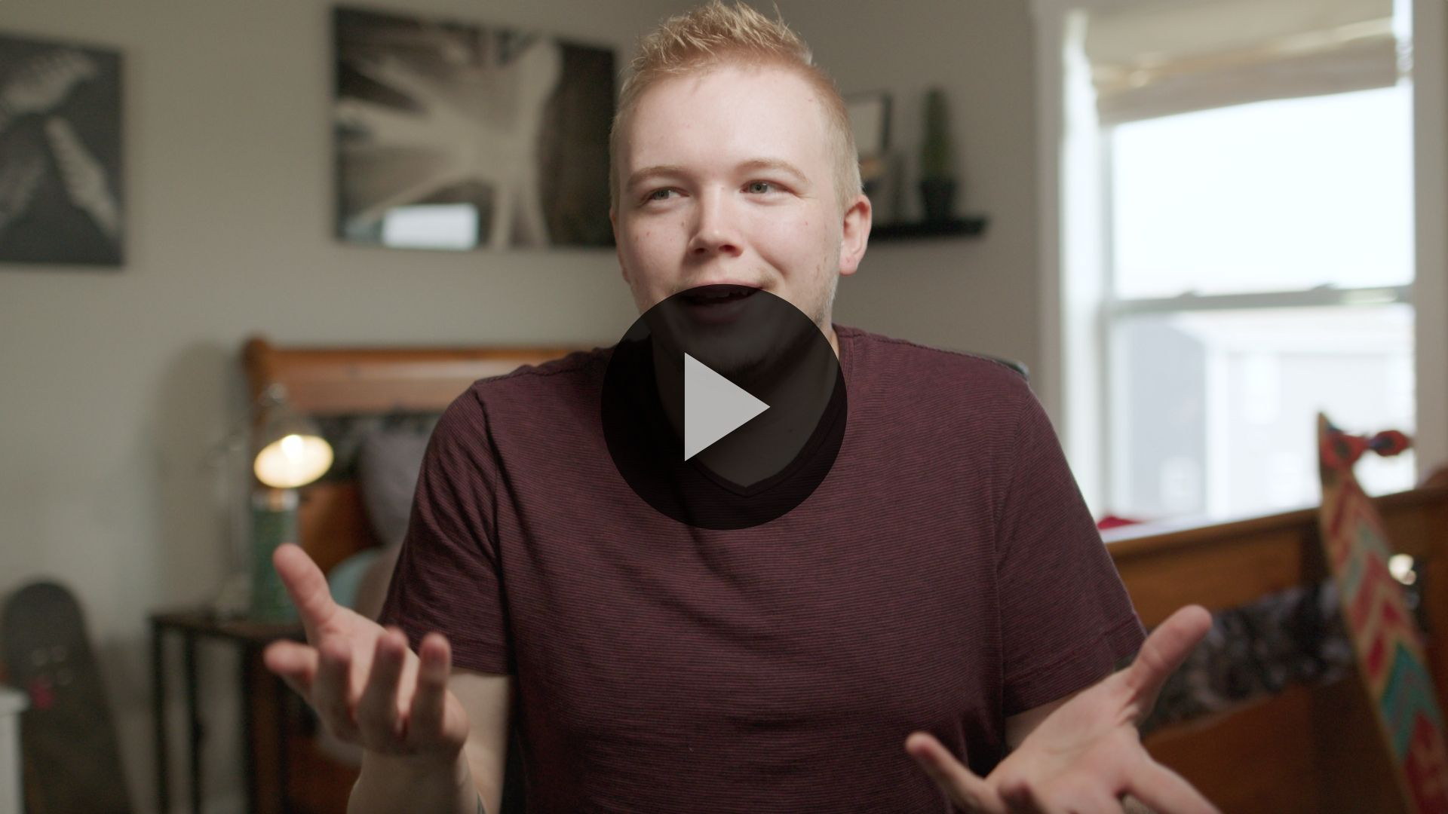

**Consider What the Bible Says**

*Ensure each student has access to a Bible, preferably the same version.*

|  |
| --- |
| **QUESTION**  How would you define fear? What about anxiety? What do they feel like? |

Anxiety and fear are real. Sometimes our circumstances can be scary or even look hopeless. When we’re afraid, we can be tempted to let fear influence our decisions. If those feelings of fear and worry don’t go away, anxiety can set in. We might feel tense, irritable, or tired. Or the opposite happens, and it’s hard to sleep much at all.

But these feelings are never bigger than God. God’s love and His great plan for our life can beat out our biggest fears. We can have peace because the God we serve is bigger than the hardships we face.

**Even When Life Gets Scary, God Is with Us**

|  |
| --- |
| **QUESTION**  Do you think Joseph felt afraid or anxious? Why or why not? |

Today’s Bible verses pick up about thirteen years after Joseph’s brothers had told their dad that Joseph had been killed. Instead, the brothers had sold Joseph as a slave. Then he was unfairly thrown in prison. He seemed to be forgotten by everyone.

But one day, Pharaoh had a dream no one could interpret. His cupbearer remembered Joseph! Joseph not only interpreted Pharaoh’s dream but also provided a wise plan for the upcoming famine.

Read [Genesis 41:39–41](https://ref.ly/logosref/Bible.Ge41.39-41); [42:1–4](https://ref.ly/logosref/Bible.Ge42.1-4).

|  |
| --- |
| **QUESTION**  Why did Pharaoh put Joseph in charge? |

Even though Joseph had a rough journey leading up to this moment, he now found himself in a position of great authority. He was second in command over what was likely one of the most powerful nations in the world. Joseph’s dreams that he had many years earlier were finally coming to pass in God’s perfect timing. Joseph’s godly wisdom led him to store up loads of grain right before a time of famine. The fulfillment of his dreams wasn’t just about him. It offered opportunities for his family to survive.

|  |
| --- |
| **QUESTION**  Why do you think Jacob refused to allow Benjamin, his youngest son, to go with his brothers to Egypt? |

Jacob was terrified of losing his youngest son, Benjamin. He was overly protective, which was rooted in fear. After all, he still believed that he had already lost one son. We can be like this sometimes. Whenever we’re afraid of losing something or someone we love, we hold on tighter out of fear.

|  |
| --- |
| **QUESTION**  How can fear prevent us from making good decisions? |

**Did You Know?**

*Although Egypt is consistently portrayed as a desert, in ancient times it had one of the world’s most constant sources of food due to the predictable flooding cycles of the Nile River. This allowed for the development of strong agricultural systems along the river and in the Nile delta. Although famine and drought had devastating effects on the nearby regions, Egypt usually had a consistent supply of food because they were not dependent upon the rains. Therefore, Egypt was a source for those desperately seeking help in times of famine, such as Jacob and his family.*

**When We Step Out, God Guides Us**

Read [Genesis 45:3–9](https://ref.ly/logosref/Bible.Ge45.3-9), [16–18](https://ref.ly/logosref/Bible.Ge45.16-18).

In the previous chapter, Joseph’s brothers had bowed down to him just like in his dream. And here, Joseph revealed to his brothers that he was alive. Imagine seeing someone you sold as a slave and thought you’d never see again right in front of you! Not only that, but he was the governor of a great nation. Then imagine that he controlled all the resources you desperately needed at the time.

|  |
| --- |
| **QUESTION**  How do you think Joseph’s brothers felt, knowing that Joseph was not only alive, but was a powerful leader? |

They were probably shocked—and scared—to discover he was still alive! They probably wondered if Joseph would pay them back for what they had done to him. But he chose to see the situation from God’s perspective.

|  |
| --- |
| **QUESTION**  Has anyone ever wronged you, and it turned out for good? What happened? |

|  |
| --- |
| **QUESTION**  How does knowing Joseph’s story help you understand how God works behind the scenes in each person’s life? |

God was never absent from Joseph’s life, even when he was going through terrible things. This whole time, God was working behind the scenes to protect and provide for Joseph and his family.

|  |
| --- |
| **QUESTION**  Based on this example, why do you think God allows us to go through tough times? |

Sometimes our own bad decisions create situations that lead to pain. Other times God may allow something in order to get us to a place where He can fulfill His plan. Joseph had to choose to keep trusting God no matter what happened.

|  |
| --- |
| **QUESTION**  Have you ever doubted God was with you? Why or why not? |

|  |
| --- |
| **QUESTION**  Why do you think we still have fears even though we know God is bigger than our fears? |

**When We Trust God, He Meets Us**

Read [Genesis 46:1–5](https://ref.ly/logosref/Bible.Ge46.1-5).

Joseph’s brothers went back to get their families and move to Egypt. They had great news to share with Jacob—not only was Joseph alive, but he was the governor of Egypt! Jacob would be reunited with Joseph. But first, Jacob had to face his fear of making the trip.

|  |
| --- |
| **QUESTION**  What did God say to Jacob? |

|  |
| --- |
| **QUESTION**  Have you ever had a time when you felt God tell you that everything was going to be okay? Explain. |

|  |
| --- |
| **QUESTION**  What did God promise to Jacob in the vision He gave to him? How did this strengthen Jacob’s faith? |

Not only did God tell Jacob not to fear, but God also gave him an amazing promise—his family would be made into a great nation.

|  |
| --- |
| **QUESTION**  How does fear try to destroy our faith? |

|  |
| --- |
| **QUESTION**  Do you think it’s possible to grow in your faith when living with fear? Why or why not? |

**Reflect**

**God Helps Me with Fear and Anxiety**

Sometimes we can be tempted to let fear influence our decisions. But God never leaves us. Even though we experience fear, God is trustworthy. God is always working on our behalf, even when we can’t see it. God always loves us, even when we can’t feel it. He loves us so much! Fear is not from God. He promises to be with us in whatever we face. Do not fear because God is greater than any difficulty!

But you may face times that even knowing God is greater may not overcome all your fear. Sometimes it’s good to hear it from someone else. Hearing the testimony that Joseph was alive was part of what helped Jacob overcome his fear of moving his family. We can experience this within the Church. As a follower of Jesus, the community you’re a part of can offer help when you’re overwhelmed with fear and anxiety. Their experiences can strengthen you. Never hesitate to find a trusted leader or mature Christian to talk to about unresolved fears. It’s possible that they’re a part of God’s answer for your need.

**Listen to God**

Let’s take time to consider how our life demonstrates a real trust in God. These questions are meant to serve as a conversation between you and God. Sharing your responses with the group is completely voluntary.

• *Pause for a few moments of silent reflection before asking students if they want to share.*

|  |
| --- |
| **QUESTION**  What is something that you used to fear or worry about, but God has helped you to overcome? |

|  |
| --- |
| **QUESTION**  What is something that you fear or you’re worried about now that you need to give to God? |

|  |
| --- |
| **QUESTION**  Do you have fears that you need to talk about? Is there something in your life that’s unresolved, and you’ve struggled to overcome it? Who could God use to share your burden? |

**Activate**

As you reflect on fear and anxiety, ask God to remind you of His presence. Even though anxiety and fear are real emotions, God is greater than anything we face. He wants to give you His peace. Because of Jesus, we can overcome fear and anxiety in our life.

Sometimes we need others to help us. Don’t hesitate to talk to someone if you have a fear or anxiety that you just can’t seem to give to God. We can pray for others who face fear too. Choose one or two people who shared a fear they have with the group. Throughout this week, pray for them whenever they come to mind.

|  |
| --- |
| **Salvation Opportunity**  *Include this if you think there may be some in the group who do not have a personal relationship with Jesus.*  Overcoming fear and anxiety through Jesus starts with having a relationship with Him. Anxiety is not from God. He can calm any fear we face, regardless of how hard it may feel. God sent His one and only Son, Jesus Christ, to save us because He loves us so much. He knows everything about us, including the emotions we feel. God stands ready to forgive you for any sin you’ve committed against Him. All you have to do is ask Him to forgive you and accept Him as your personal Lord and Savior.  **Is there anyone here that we can pray for who doesn’t have a relationship with Jesus or wants to renew their relationship with Him?**  *Take a moment to acknowledge those who respond, and thank them for their desire to make things right between themselves and God. Pray with them as we close in prayer or after the group time is over. Following group time, talk more about where they are in their walk with God and how you might be able to help.* |

**Conclusion**

Life can be hard and even painful. But the example of Joseph reminds us that God never leaves us, no matter how difficult things may be. No fear that you face can separate you from His love for you. God’s Spirit inside every believer is greater than the enemy who is against you. Because of Jesus, we can be free from fear!

**Prayer**

Heavenly Father, thank You that Your love is greater than fear. Thank You for being with us, helping us, and delivering us from fear. We declare that You are the One True Great Almighty God, and You are undefeated. Help us to give our fears to You. With You, our anxiety can be defeated through Your great love. We are Yours, and You are ours. We need You every moment of every day of our life. We trust You. In Jesus’ name, we pray. Amen.

Don’t forget the personal devotions provided for you on the app. I’ll see you next time as we continue studying God’s Word together!